Deliverable 4: Integration and Security Implementation
Vikram Reddy Tekula, Raghav Gurram
Shiva Gowtham Kumar, Sri Varshini Sukhamanchi
University of the Cumberlands
Advanced Operating Systems (MSCS-630-M20)
Professor Sean Perryman
October 25, 2026

Introduction
Operating-system shells coordinate command execution, process creation, resource allocation and access to stored information. The final deliverable combines the previously developed Python shell with command pipelines and a teaching-oriented authentication and authorization layer. It preserves Unix process management but combines simulated scheduling, paging, page replacement and producer–consumer synchronization. The goal is to show integrated system behavior and explain the boundary between a shell-level simulation and kernel-enforced protections. Recent access-control work argues that authentication decisions and authorization policy must be consistent to prevent unauthorized operations.
Integration Overview
The original shell used os.fork(), os.execvp(), os.waitpid(), job tables, terminal process groups and built-in commands. Deliverable 2 added a Scheduler module with configurable Round-Robin and preemptive priority simulations (waiting time, turnaround time and response-time metrics), a Paging object with fixed-size frames, FIFO and LRU replacement, fault counters and per-process residency, plus a bounded producer–consumer demonstration using mutexes and counting semaphores in Deliverable 3. Deliverable 4 keeps these modules but adds an authentication gate, role-protected demonstration workspace and multiprocess pipelines (Chen et al., 2024). Scheduling is still virtual CPU-time simulation; paging does not change physical RAM; synchronization uses Python threads (not forked-job control).
Piping Implementation
A pipeline parser splits unquoted pipe operators into stages (ignores empty stages and unsupported redirection combinations). For each stage, the parent opens os.pipe(), forks a child, connects the previous pipe read end to standard input and the following pipe write end to standard output using os.dup2(), and external stages call os. execvp; stateless shell built-ins run inside child processes flush their output before exiting; parent closes redundant descriptors and waits for all children. Three-stage example "echo Alpha error Beta | grep error | tr a-z A-Z" gives ALPHA ERROR BETA. Shell state-changing commands are deliberately not in pipelines so that changes on the child side do not seem to modify parent state. This shows byte stream coordination between processes without claiming POSIX pipeline semantics or background job control over pipelines.
Authentication and Security Controls
Before showing its command prompt, the integrated shell asks for a username and password (two demonstration users, admin and student, have different roles and examples of credentials). Password verification uses salted PBKDF2-HMAC-SHA256 hashes and constant-time comparison, but passwords are seeded in program code so coursework demonstrations can be reproducible; they cannot be deployed unchanged, and three attempts limit interactive guesses.
A separate secure command allows role-controlled read, write and simulated execute operations on a workspace: administrators can update system/policy.txt; standard users can read that policy but not modify or execute system files; standard users may modify their own user directory and shared content; path normalization prevents parent-directory traversal and symlink escapes (Billoir et al., 2024). These controls illustrate least privilege, which is an important goal of administrative access design.
Execution Evidence and Findings
Four runs were recorded to check the integration: the pipeline chain produced uppercase filtered output (with success exit status) and wrote a simulated system policy; administrator authenticated and wrote it; student authenticated separately, read the policy (got access denied when trying to change it), and edited a personal file successfully. Integrated tests also ran preemptive scheduling, LRU page access and a bounded-buffer synchronization example. Deliverable 3 performance on a 12-reference three-frame workload was nine FIFO faults versus eight LRU faults (these are for that test only, not general algorithm superiority). Below are screenshots of demonstrations; each is drawn from an actual execution log and not a direct desktop photo.
Figure 1. Three-stage pipeline
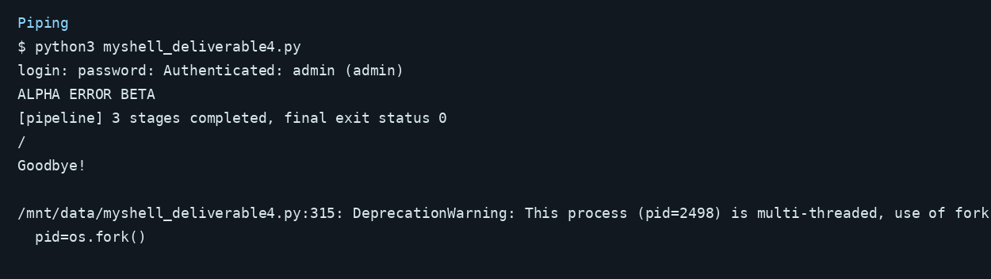
Figure 2. Administrator login and permissions
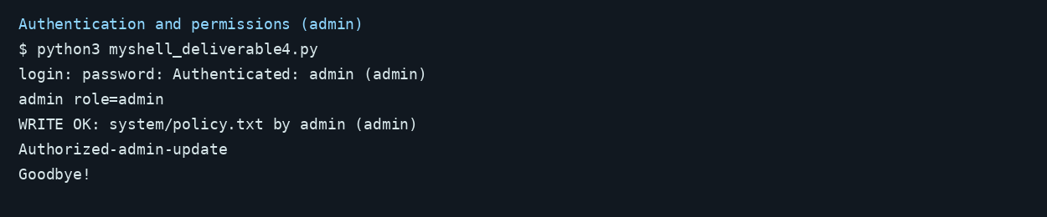
Figure 3. Standard-user access control
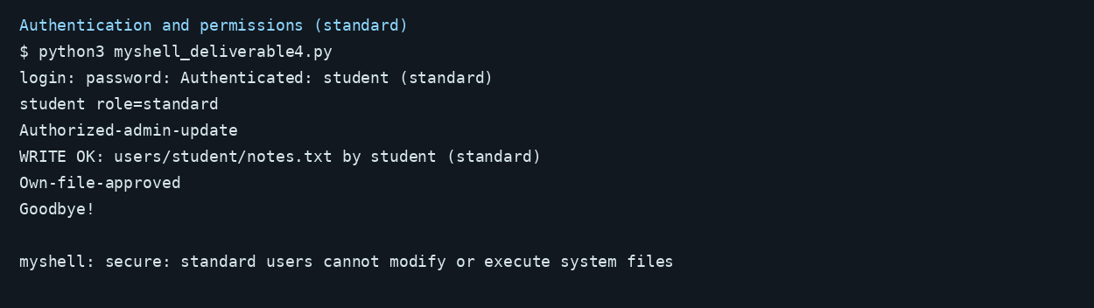

Figure 4. Integrated modules
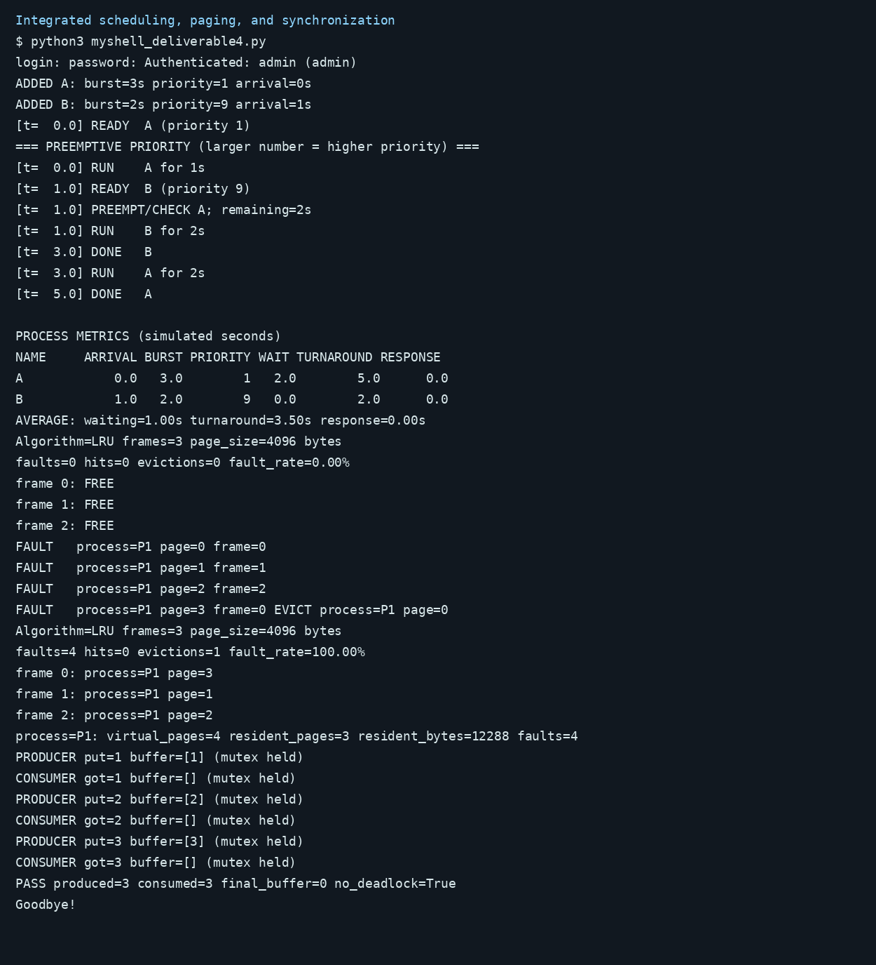

Security Limitations and Research Implications
A simulated role store is not an operating-system security boundary: existing external commands (and ordinary shell builtins) still run with the host account privileges; they can access host files independently of secure command. Thus, this demonstration is not kernel-level isolation, protection against malicious users or multiuser account management. Policy extraction research shows why access rules should be verified independently from intended policy (Le et al., 2022). Authentication research shows contextual policies and insecure adaptations. Production extension would enforce access through Unix ownership/permissions/separate host user identities or containers, audit records, lockout protections and centrally managed credential storage.

Challenges and Improvements
The main integration challenge was keeping earlier job control while introducing new pipe descriptors and authentication state; dedicated modules reduced coupling, and excluding state-changing built-ins from pipelines prevented misleading side effects. Resource management challenges were ensuring that parent and child close unused descriptors, preventing pipeline readers from being blocked, and distinguishing simulation measurements from operating system measurements.
A second challenge was traversal beyond the role-controlled root; canonical path checks solved this teaching scenario. Future development should add POSIX pipeline process groups, signal forwarding, background pipelines, filesystem permission tests, account provisioning and encrypted configuration (Singh et al., 2024). Role-governance research shows complex access policies benefit from formal administration and consistency checks.

Conclusion
The integrated shell provides a cohesive educational model of process control, CPU scheduling, paging, page replacement, synchronization, command piping and role-based file access. Execution tests show pipeline communication, separate user logins and rejection of an unauthorized update to the system file. Its main value is that operating-system mechanisms are observable and testable. Because the permission layer is simulated, security deployment would need stronger host-level isolation, credential handling and auditing before use outside the lab.
References
Billoir, E., Laborde, R., Wazan, A. S., Rütschlé, Y., & Benzekri, A. (2024). Implementing the principle of least administrative privilege on operating systems: Challenges and perspectives. Annals of Telecommunications, 79, 857–876. https://doi.org/10.1007/s12243-024-01033-5
Chen, J., Hengartner, U., & Khan, H. (2024). MRAAC: A multi-stage risk-aware adaptive authentication and access control framework for Android. ACM Transactions on Privacy and Security, 27(2), Article 17, 1–30. https://doi.org/10.1145/3648372
Le, H. T., Shar, L. K., Bianculli, D., Briand, L. C., & Nguyen, C. D. (2022). Automated reverse engineering of role-based access control policies of web applications. Journal of Systems and Software, 184, 111109. https://doi.org/10.1016/j.jss.2021.111109
Singh, M. P., Sural, S., Vaidya, J., & Atluri, V. (2024). A role-based administrative model for administration of heterogeneous access control policies and its security analysis. Information Systems Frontiers, 26(6), 2255–2272. https://doi.org/10.1007/s10796-021-10167-z

